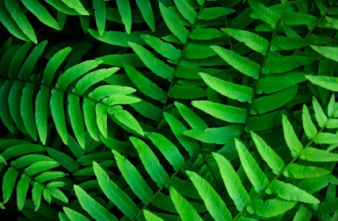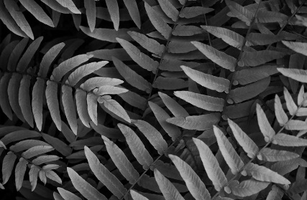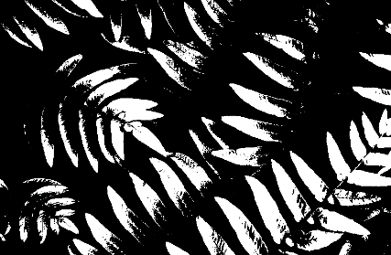**Threshold**

**Fig.** 1 Original **Fig.** 2 Gray scale image **Fig.** 3 Threshold image

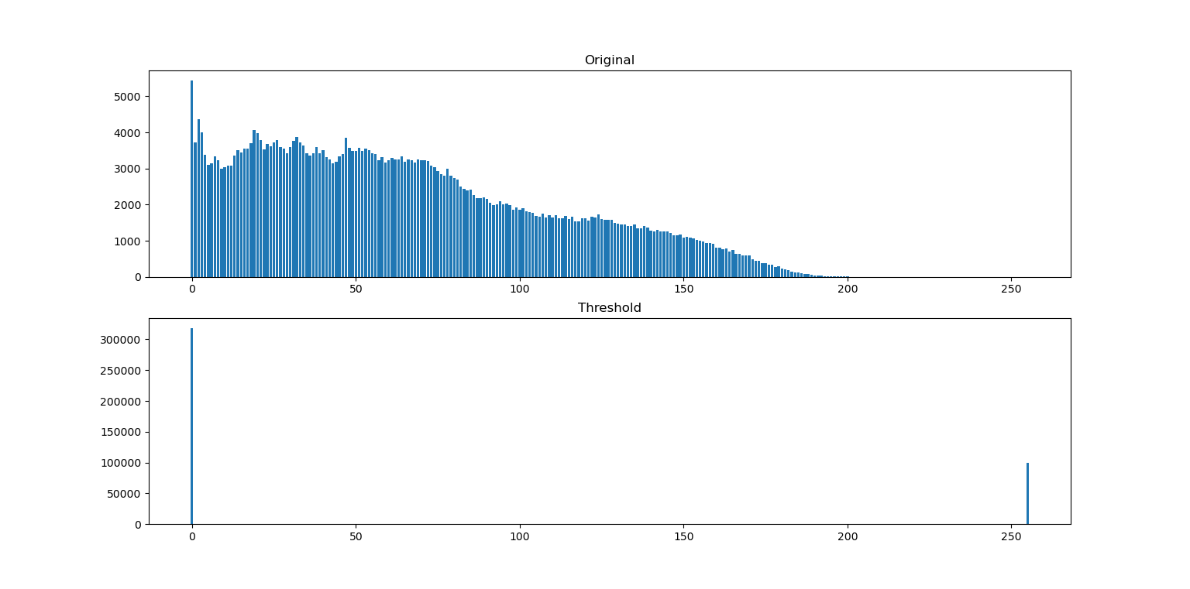

Threshold = 100

**Fig.** 4 Compare histogram of original image and threshold image

From Fig. 4, I chose threshold at 100. Histogram of threshold image have only 0 and 255 and threshold image have only white and black colors.

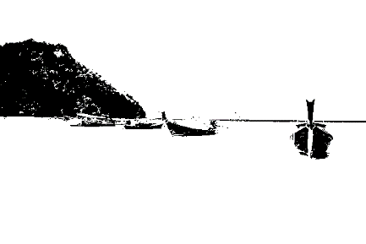

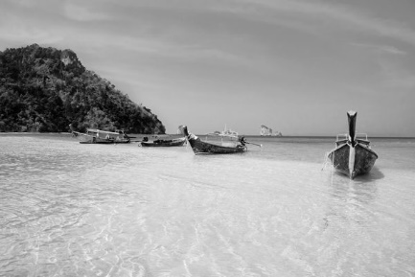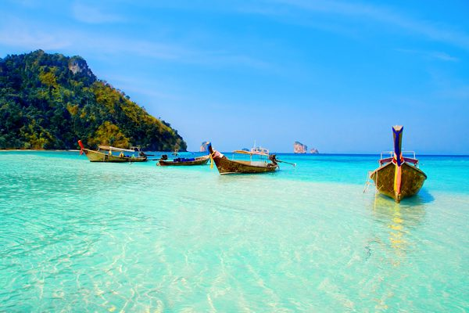

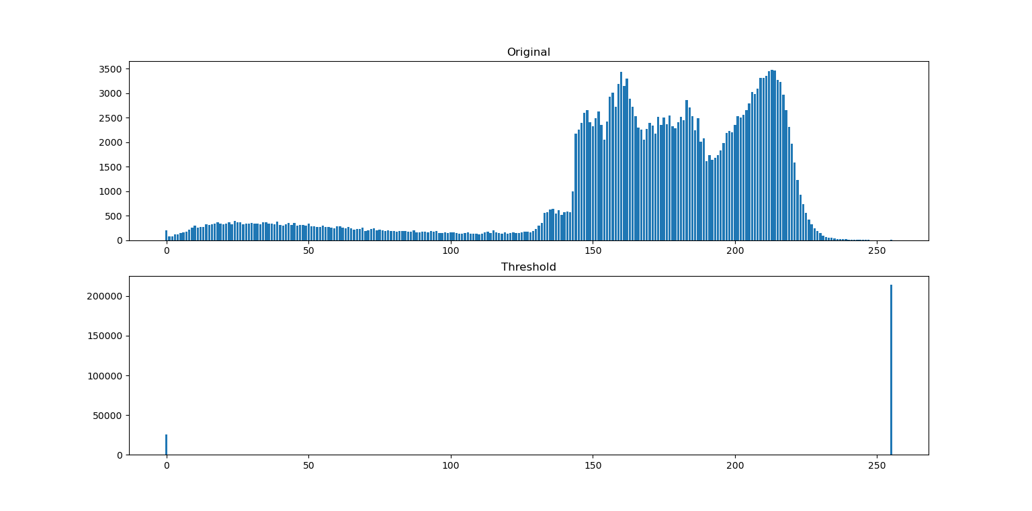 **Fig.** 5 Original  **Fig.** 6 Gray scale image  **Fig.** 7 Threshold image

Threshold = 100

**Fig.** 8 Compare histogram of original image and threshold image

From Fig. 8, I chose threshold at 100. Histogram of threshold image have only 0 and 255 and threshold image have only white and black colors.

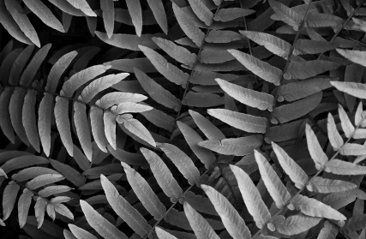**Automatic Contrast Adjustment**



**Fig.** 9 Original **Fig.** 10 Gray scale image **Fig.** 11 Auto-contrast image

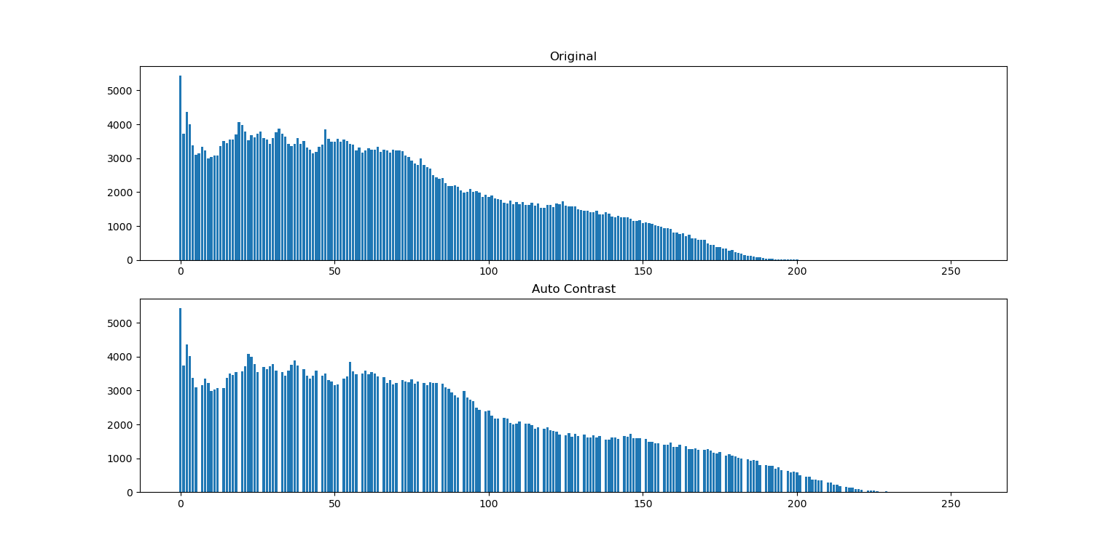

Gap

**Fig.** 12 Compare histogram of original image and auto-contrast image

From Fig. 12, I chose amin = 0 and amax = 255. Histogram of auto-contrast image have gap and auto-contrast image has high contrast

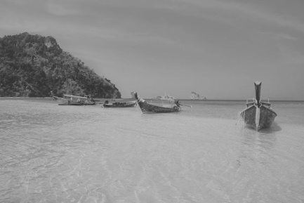



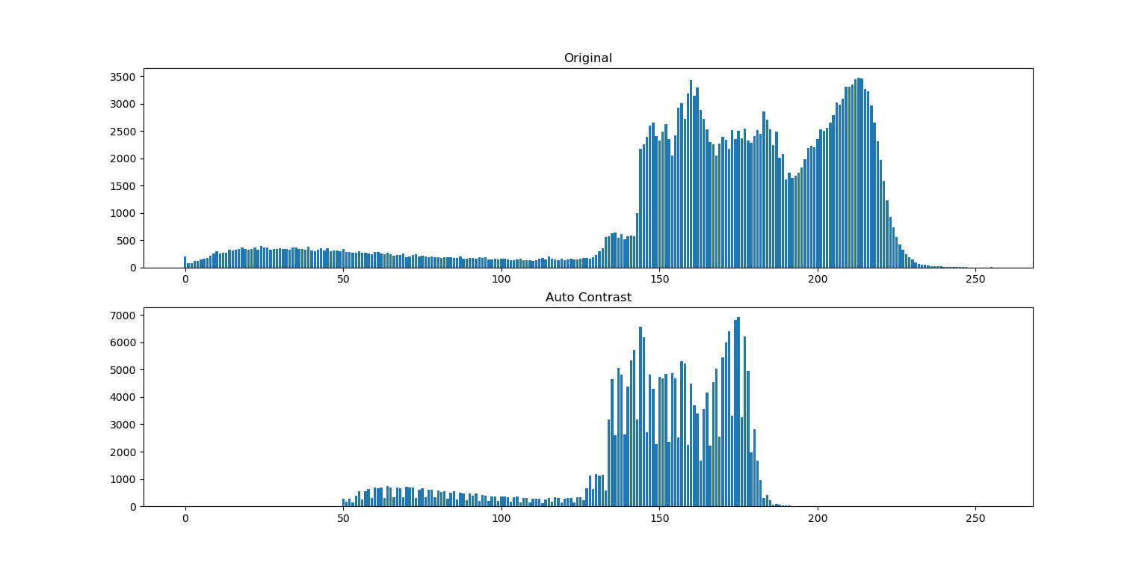 **Fig.** 13 Original  **Fig.** 14 Gray scale image  **Fig.** 15 Auto-contrast image

Spike

**Fig.** 16 Compare histogram of original image and auto-contrast image

From Fig. 16, I chose amin = 50 and amax = 200. Histogram of auto-contrast image have range of intensity between 50 and 200, it has spike and auto-contrast image has low contrast

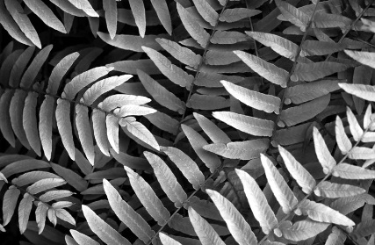**Modified Auto-Contrast**

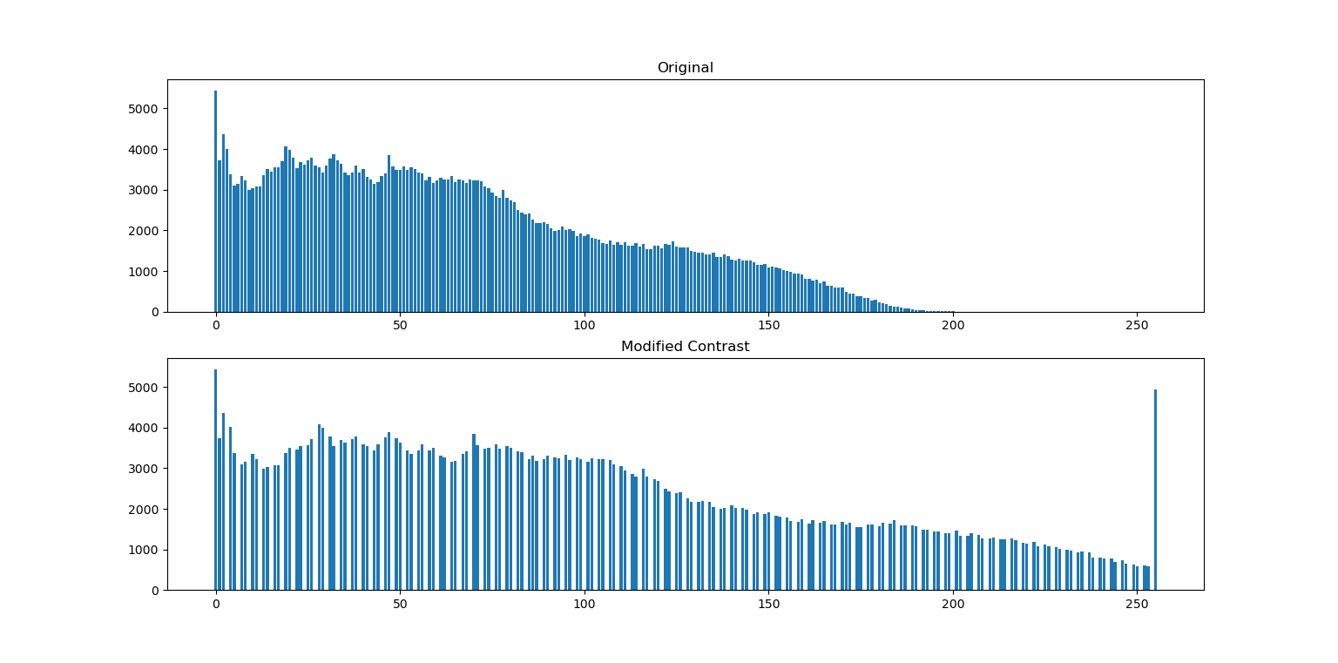 **Fig.** 17 Original  **Fig.** 18 Gray scale image  **Fig.** 19 Modified Auto-Contrast

Gap

**Fig.** 20 Compare histogram of original image and modified auto-contrast image

From Fig. 20, I chose qlow = 0.01, qmax = 0.01, amin = 0 and amax = 255. Histogram of modified auto-contrast image have range of intensity between 0 and 255, it has gap and modified auto-contrast image has high contrast

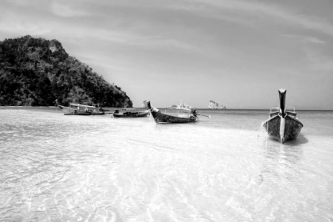

**Fig.** 21 Original  **Fig.** 22 Gray scale image  **Fig.** 23 Modified Auto-Contrast

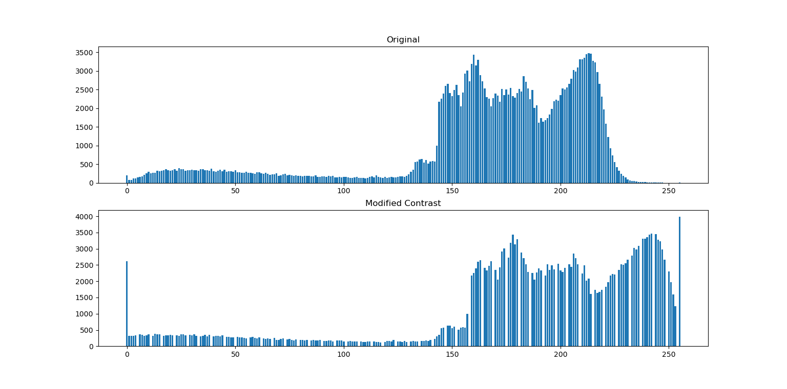

Gap

**Fig.** 24 Compare histogram of original image and modified auto-contrast image

From Fig. 24, I chose qlow = 0.01, qmax = 0.01, amin = 0 and amax = 255. Histogram of modified auto-contrast image have range of intensity between 0 and 255, it has gap and modified auto-contrast image has high contrast

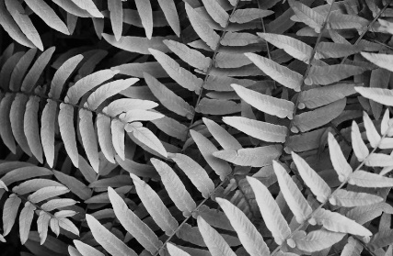**Histogram Equalization**

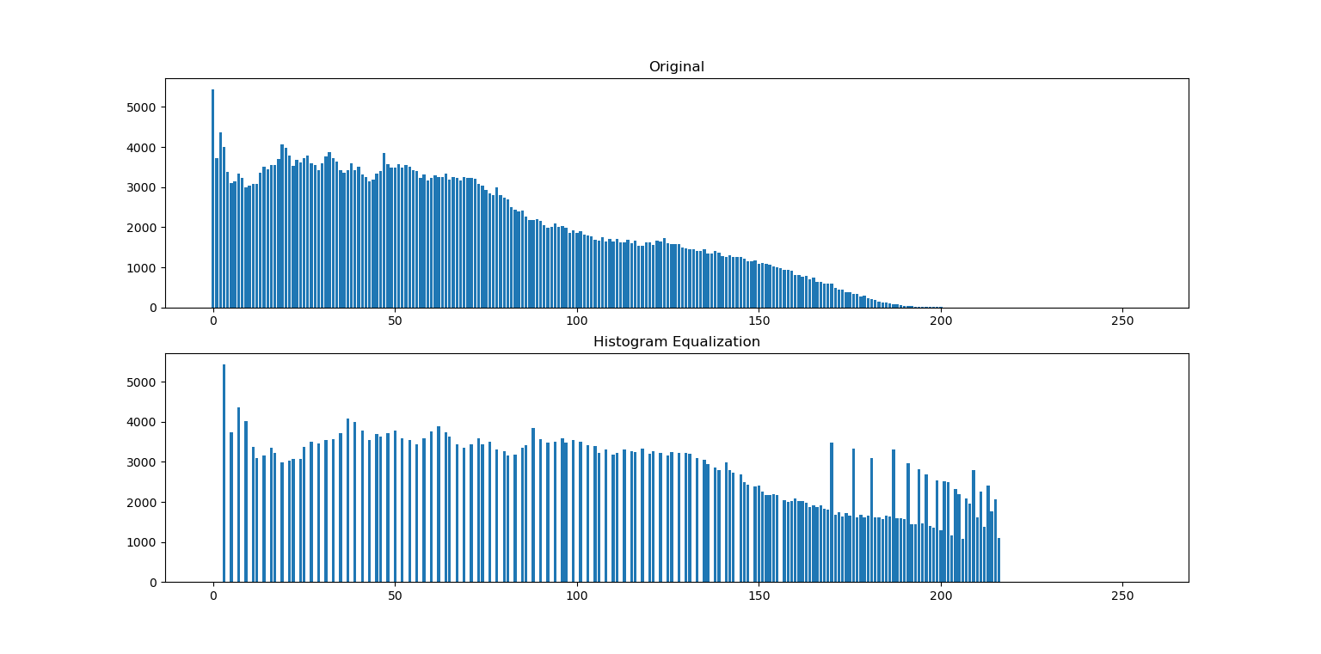**Fig.** 25 Original **Fig.** 26 Gray scale image **Fig.** 27 Histogram Equalization

Spike

Gap

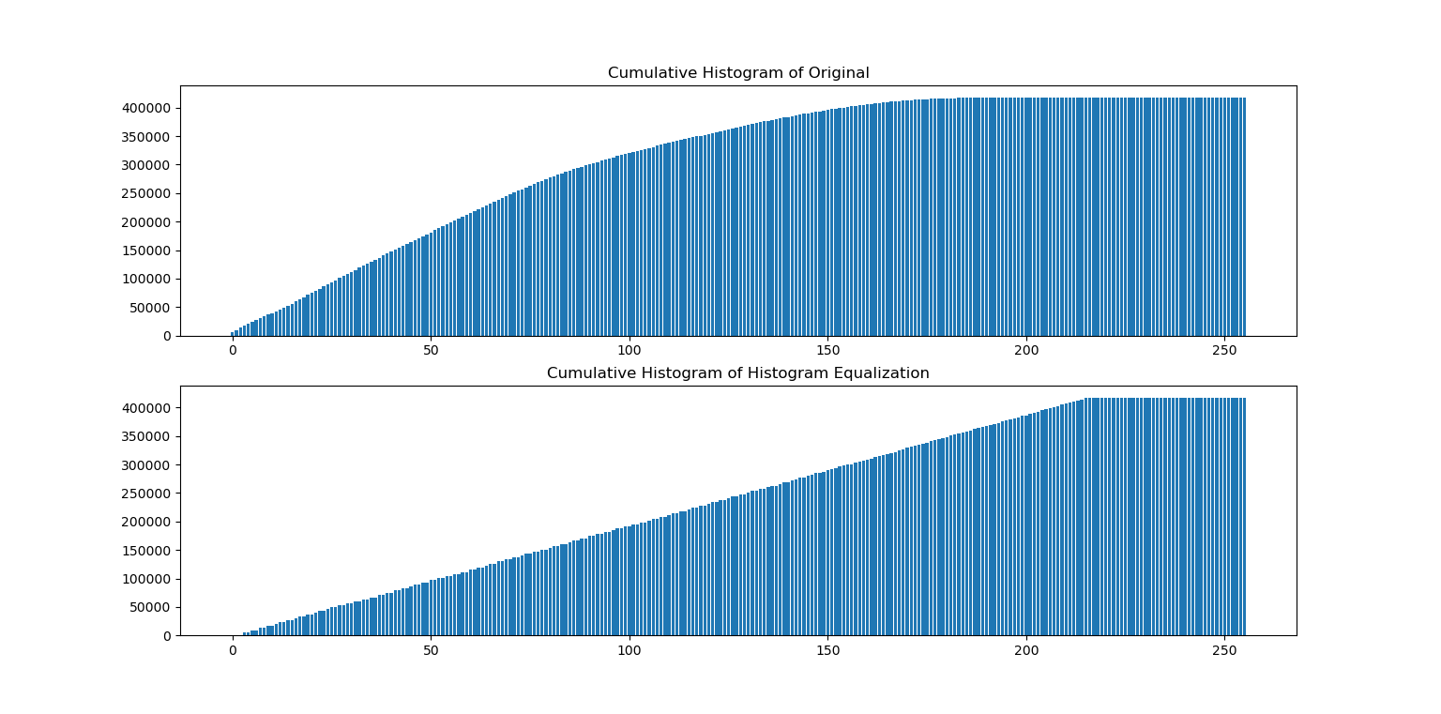**Fig.** 28 Compare histogram of original image and histogram equalization image

**Fig.** 29 Compare cumulative histogram of original image and histogram equalization image

From Fig. 28, histogram of histogram equalization image has gap and spike and range of intensity is same range of original. And from Fig. 29, cumulative histogram of histogram equalization image is uniform

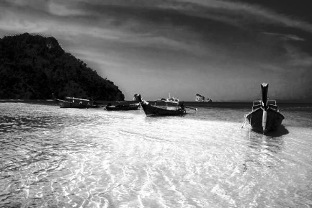****

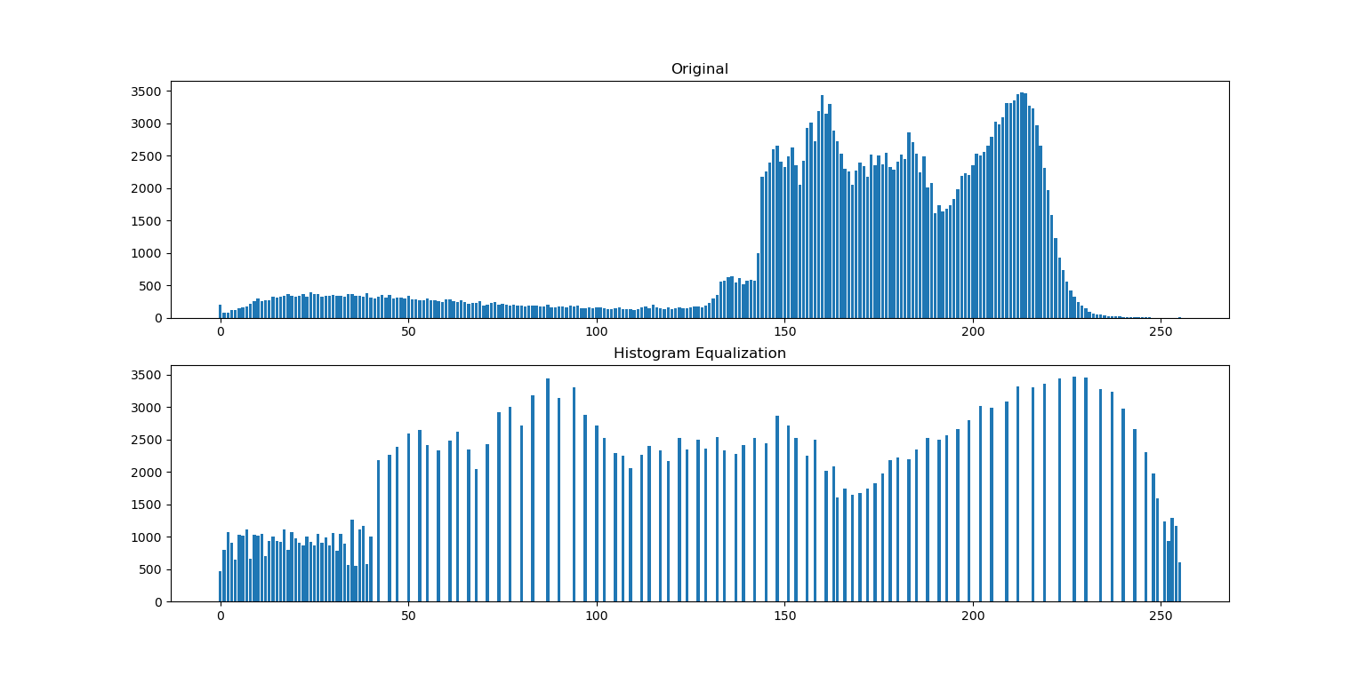**Fig.** 30 Original **Fig.** 31 Gray scale image **Fig.** 32 Histogram Equalization

Gap

**Fig.** 33 Compare histogram of original image and histogram equalization image

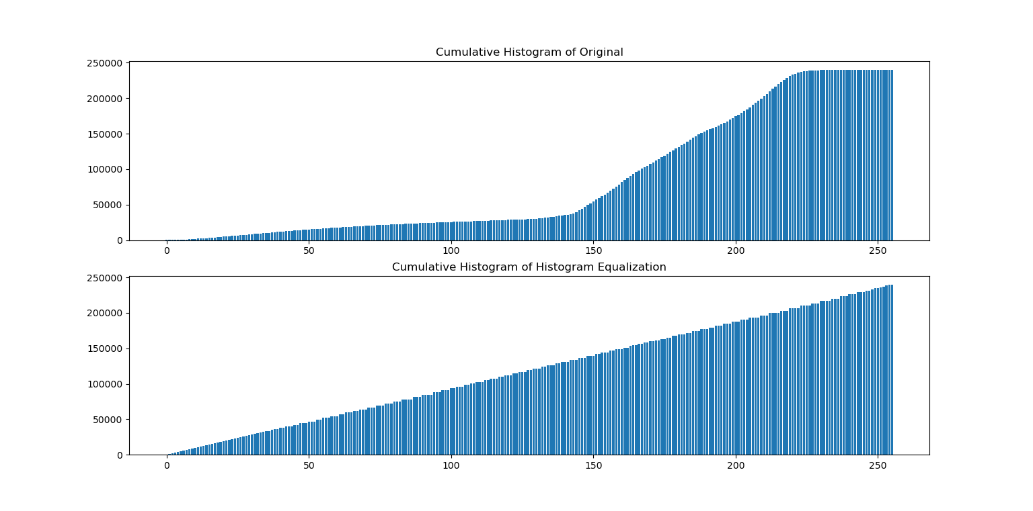

**Fig.** 34 Compare cumulative histogram of original image and histogram equalization image

From Fig. 33, histogram of histogram equalization image has gap and range of intensity is same range of original. And from Fig. 34, cumulative histogram of histogram equalization image is uniform